RESUME
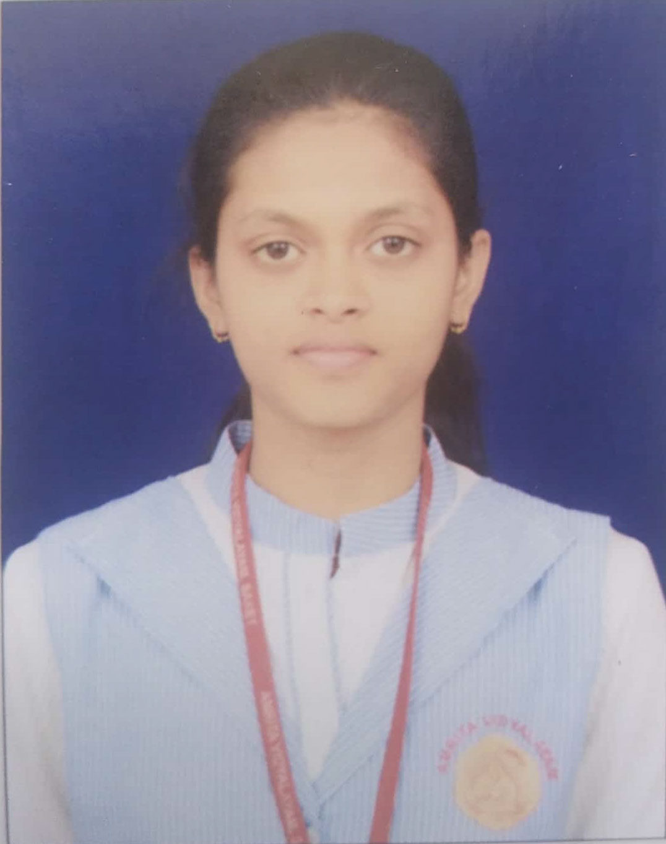
Name: Avipsa Pradhan
Address: 602, Global Heights, Sector-33, Sohna, Gurugram, 122103
Email ID: avipsapradhan2003@gmail.com
Contact No: 8700602759
Linkedin Profile link: https://www.linkedin.com/in/avipsa-pradhan-42321a235/

CAREER OBJECTIVE:
- To be the part of an enthusiastic work environment, where I can use my technical skills to accomplish organizational goals.

ACADEMIC BACKGROUND:
Pursuing B.Tech in COMPUTER SCIENCE ENGINEERING & TECHNOLOGY from Dronacharya college of Engineering, Gurugram, Approved by AICTE.

Institute/University | Degree/Examination | Percentage | Year
Dronacharya College of Engineering | B.Tech | Pursuing(1st year) | ------
HPS, New Delhi | 12th | 92.6% | 2021
HPS, New Delhi | 10th | 89.8% | 2019

TECHNICAL SKILLS:

- Language: Basic concepts of Python, HTML.
- Operating Systems: Windows10

WORKSHOPS AND TECHNICAL EVENTS:

- Attended two days Web Development Workshop at Dronacharya College of Engineering in December 2021.
- Attended Drone workshop at Dronacharya college of Engineering in December 2021.

ACHIEVEMENTS:

- Won the 1st prize in debate competition held in school.
- Won the 3rd prize in district and zonal level singing competition.
- Won the 1st prize in interschool dance competition.

STRENGTHS:

- The ability to Work in a team.
- Leadership Qualities.
- Hard-working with lots of patience.

EXTRACURRICULAR ACTIVITIES:

- Was a part of my school’s dance group.
- Won prizes at school for singing and painting.

